

MSTAR

Using the Diagnostic Assessment
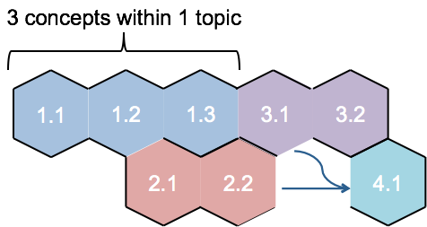
A learning progression is not unerringly accurate
but represents best instructional thinking.
A learning progression is not the one and only way,
but it represents a general projected path.

What is a Learning Progression?

According to the National Research Council, learning progressions describe ways of thinking about a topic. Learning progressions become more sophisticated as children deepen their understanding of a particular topic.

As you look at this graphic, what do you notice?

Notes:


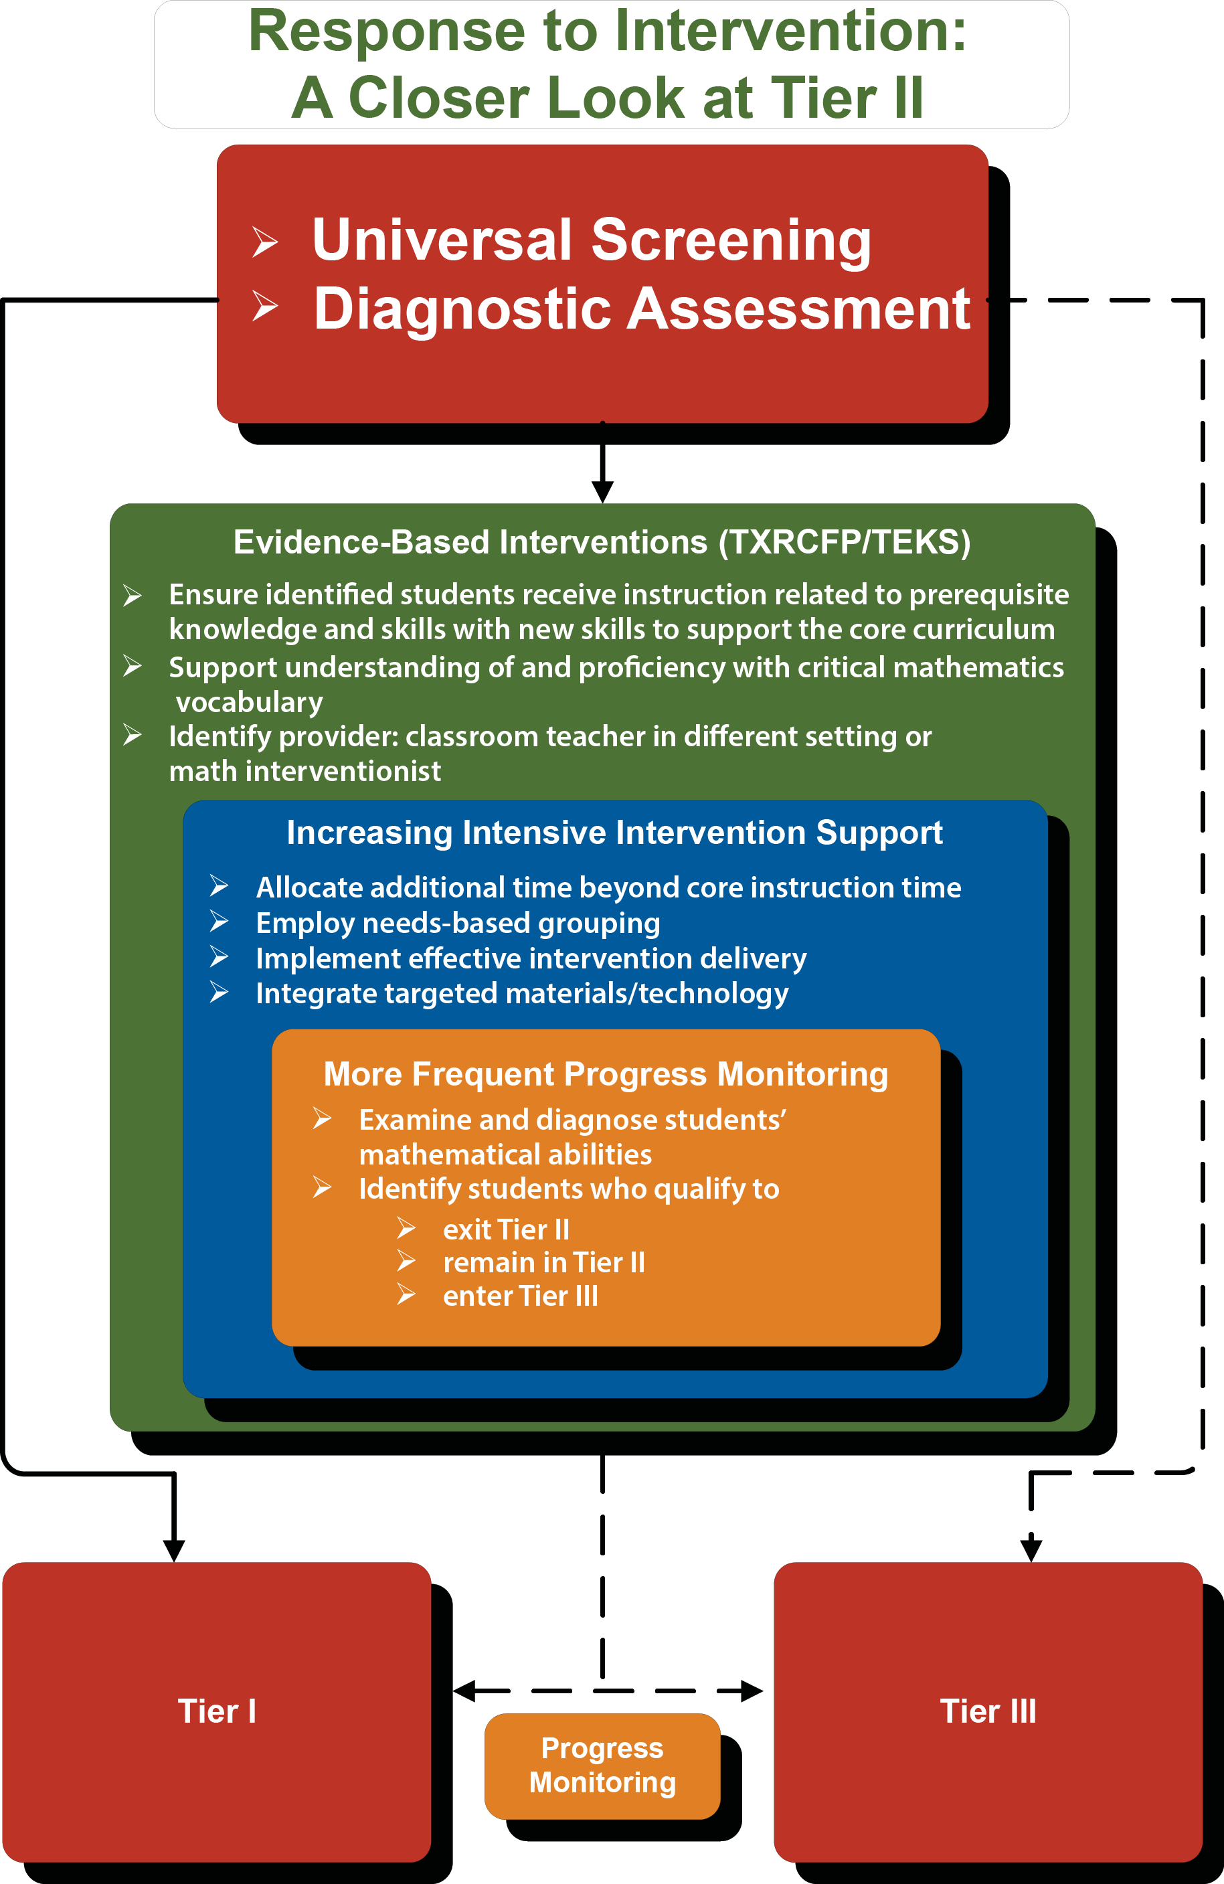
Students are given the diagnostic assessment along with progress monitoring tools. Those students who are in Tier II are given regular core instruction in addition to strategic intervention support and more frequent progress monitoring. Teachers can decide when students are able to move back into Tier I or if they need to move into Tier III for more intensive support.

Using the MSTAR Learning Progressions for Assessment

Notes:
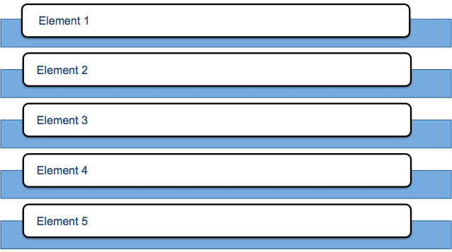
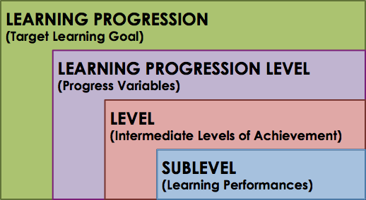

What is a Learning Progression?

Notes:
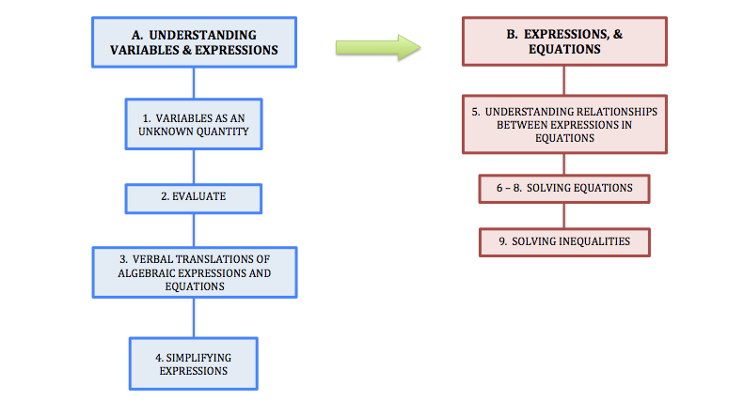
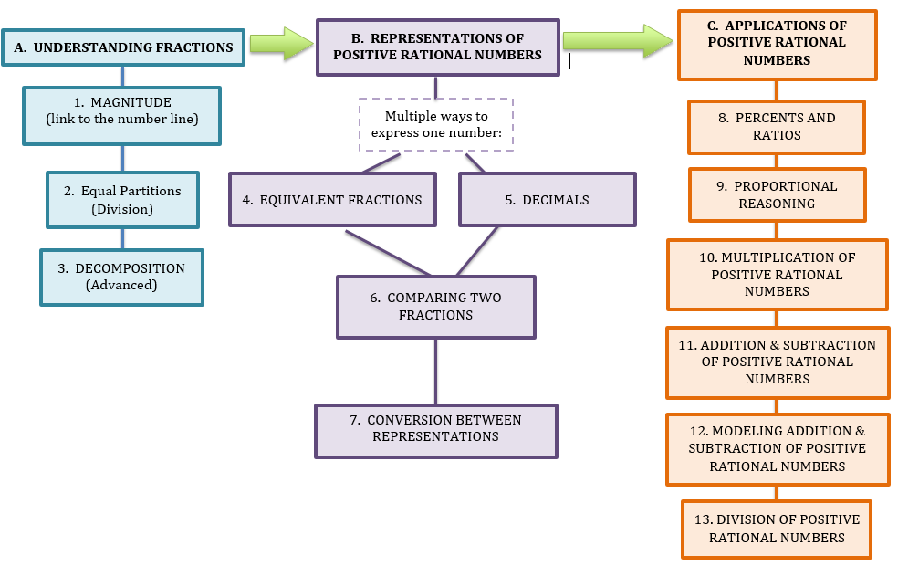

Overview of MSTAR Learning Progressions
Take a moment to reflect on concepts, skills, misconceptions, and errors that you believe may be associated with each of these levels.

A) The ones place | Student always believes the last digit is the ones place.
B) The tenths place | Student knows that the tens place is 2 digits to the left of the decimal, so the tenths place would be 2 digits to the right of the decimal.
C) The hundredths place | Correct
D) The hundreds place | Student confuses hundreds and hundredths.

Learning Progressions

What is the place value of the digit that is underlined?

2.15

Can you see some of your struggling students making these errors?

How would this information be valuable to you?

Can you see some of your struggling students making these same errors?

How would this information be valuable to you?

Which Assessment Should

My Student Take?

If it’s appropriately assigned, it will

If it’s inappropriately assigned, it will

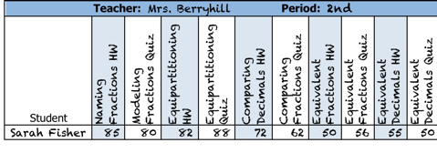
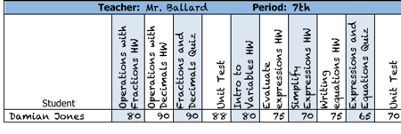
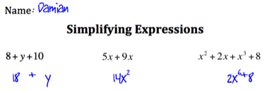


Which Assessment Should

My Student Take?

Sarah – 6th grade – Which assessment would you assign?
- She participated in the MSTAR Universal Screener.
- Spring classification: Tier 3A
- She understands basic fraction concepts but has difficulty generating different forms of rational numbers and applying rational numbers.

Damian – 8th grade – Which assessment would you assign?
- He participated in the MSTAR Universal Screener.
- Fall classification: Tier 2A
- He works well with positive rational numbers, but is currently struggling with equations and expressions in the classroom.

Julie – 5th grade – Which assessment would you assign?
- She participated in the MSTAR Universal Screener.
- Fall classification: Tier 1A
- Winter classification: Tier 1B
- Her mathematics classroom averages are
- 1st 6 weeks: 90,
- 2nd 6 weeks: 86, and
- 3rd 6 weeks: 78.
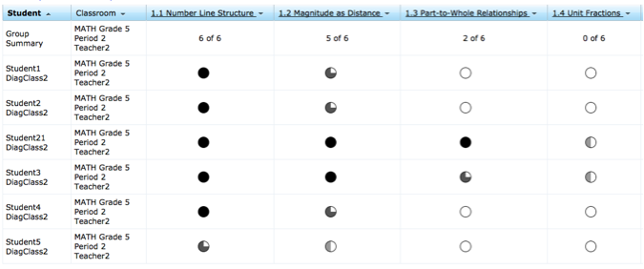

Interpreting the Student and Group Misconception Report

The Student and Group Misconception Report is intended to provide teachers and administrators with detailed information on individual student diagnostic results and misconceptions and errors. This report allows teachers to determine if students can be grouped for efficient instructional delivery.

Notes:
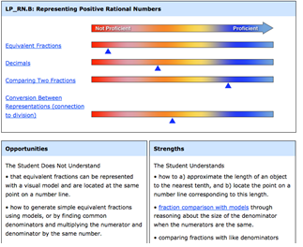

Interpreting the Student Summary Report

The Student Summary Report provides teachers with a summary of the student’s performance in an easy to understand format.

Notes:

Making Instructional Decisions

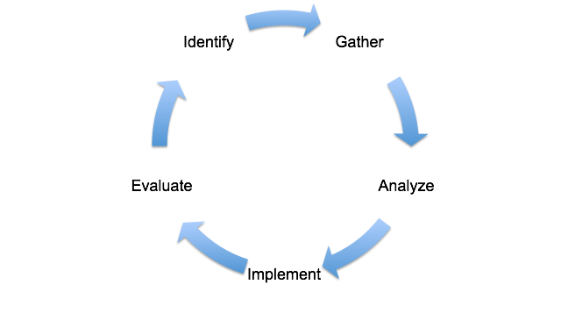
Administer a Diagnostic Assessment to struggling students.
Administer the Universal Screener to all students.
Interpret Diagnostic Results and other classroom data.
Develop and put an intervention plan into place.
Determine if the plan is working.

What new ideas do you have to implement?

Write down ideas in the learning portfolio about how you

- already support learning from data, and
- could support learning from the diagnostic results.

