Resource Build Template US History

Resource Title: OnTRACK for College Readiness US History- Social Studies Skills
Brief Description (one to three sentences):
Given information about timelines, students will be able to use the terminology correctly to explain historical concepts.
Thumbnail (file name and location): Please use the logo found in iTunes U
OnTRACK for College Readiness: US History, Module 0, Section 6 - Timelines: What are they, why are they important, and how we use them
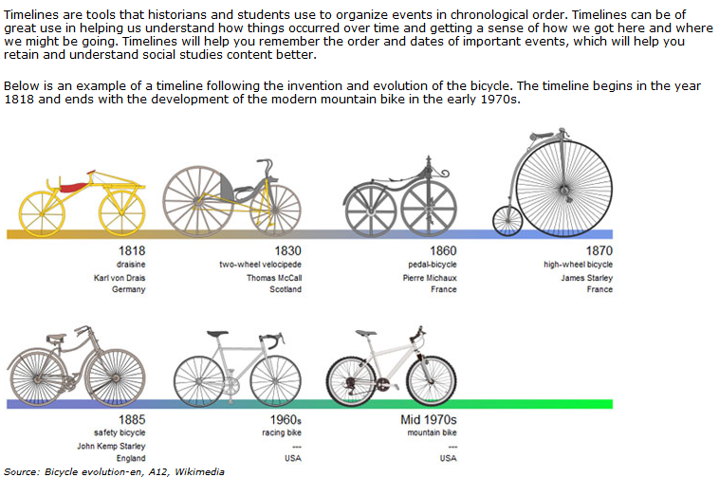
Resource Type: HTML text and image
Audience: Teachers and students in US History
Subject: Social Studies
Grade / Course: US History
Student Expectations: USH (30)(B) Social studies skills. Use correct social studies terminology to explain historical concepts.
Topic / Tag: social studies, terminology, history
Source: OnTRACK for College Readiness: US History
TEA Approved: Yes
License: Free and available for all public school teachers and students in Texas through TEA’s LMS portal
Content:
Label | Ownership | Type | Location (url)
Timelines: What are they, why are they important, and how we use them | TEA/University of Texas at Austin | HTML text | See text above, Module 0, Section 6
Bicycle Evolution | Wikimedia | image | http://commons.wikimedia.org/wiki/File:Bicycle_evolution-en.svg

Related Resources:
Title | Video url | Doc url | Link
Timeline Activity |  |  | http://www.ontrack-media.net/socialstudies/ssm0interactive7.html
 |  |  | http://ontrack-media.net/socialstudies/ssm0interactive5mobile.html

