Resource Build Template Biology

Resource Title: OnTRACK for College Readiness Biology

Brief Description (one to three sentences): Given descriptions or illustrations, students will distinguish between the major cell types.

Thumbnail (file name and location): Please use the logo found in iTunes U
OnTRACK for College Readiness: Biology, Module 1 Lesson 2, Sections 1, 2 and 3

http://www.ontrack-media.net/biology/imagemap1.html
http://www.ontrack-media.net/biology/imagemap2.html
http://www.ontrack-media.net/biology/imagemap3.html

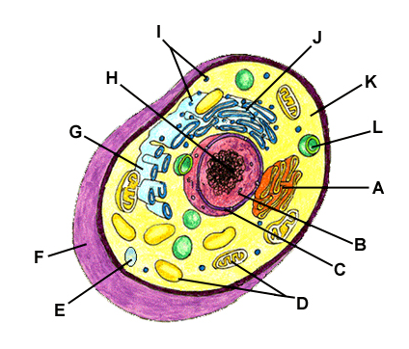
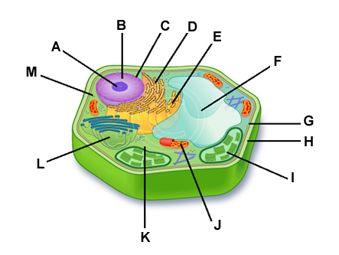
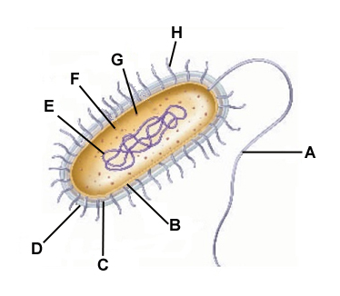

Resource Type: interactives (image maps)

Audience: Teachers and students in Biology

Subject: Biology

Grade / Course: Biology

Student Expectations:
(B4A) compare and contrast prokaryotic and eukaryotic cells;

Topic / Tag: prokaryotic, eukaryotic, bacteria

Source: OnTRACK for College Readiness: Biology

TEA Approved: Yes

License: Free and available for all public school teachers and students in Texas through TEA’s LMS portal

Content:
Label | Ownership | Type | Location (url)
Content 1 | TEA/University of Texas at Austin | interactive | http://www.ontrack-media.net/biology/imagemap1.html
Content 2 | TEA/University of Texas at Austin | interactive | http://www.ontrack-media.net/biology/imagemap2.html
Content 3 | TEA/University of Texas at Austin | interactive | http://www.ontrack-media.net/biology/imagemap3.html

Related Resources:
Title | Video url | Doc url | Link
Resource 1 |  |  | http://www.wiley.com/legacy/college/boyer/0470003790/animations/cell_structure/cell_structure.htm
Resource 2 |  |  | http://www.cellsalive.com/cells/3dcell.htm
Resource 3
Resource 4

