Resource Build Template World History

Resource Title: OnTRACK for College Readiness World History- The Mongol Empire
Brief Description (one to three sentences): Given information on the Mongol Empire, students will identify and classify changes brought to Europe, China, India, and Southwest Asia under Mongol rule.
Thumbnail (file name and location): Please use the logo found in iTunes U
OnTRACK for College Readiness: World History, Module 4, Lesson 3, Section 1
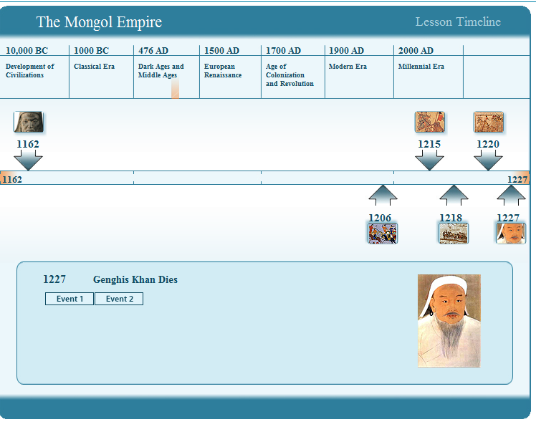
Resource Type: timeline interactive
Audience: Teachers and students in World History
Subject: Social Studies
Grade / Course: World History
Student Expectations: WH (1)(C) History. Identify major causes and describe the major effects of the following important turning points in world history from 600 to 1450: the spread of Christianity, the decline of Rome and the formation of medieval Europe; the development of Islamic caliphates and their impact on Asia, Africa, and Europe; the Mongol invasions and their impact on Europe, China, India, and Southwest Asia.
Topic / Tag: Mongol Empire, Genghis Khan
Source: OnTRACK for College Readiness: World History
TEA Approved: Yes
License: Free and available for all public school teachers and students in Texas through TEA’s LMS portal
Content:
Label | Ownership | Type | Location (url)
The Mongol Empire | TEA/University of Texas at Austin | Timeline interactive | http://ontrack-media.net/worldhistory/onTrack_WorldHistory_M4_L3_Timeline.html

Related Resources:
Title | Video url | Doc url | Link
The Legacy of Genghis Khan |  |  | http://www.lacma.org/khan/
How Stuff Works "The Truth About Nishapur" |  |  | http://history.howstuffworks.com/asian-history/genghis-khan-murder1.htm

